**CLOUD BURST PREDICTION SYSTEM**

**A MINOR PROJECT SYNOPSIS**

***Submitted in partial fulfillment of th*e *requirements for the award of the degree***

***Of***

**BACHELOR OF TECHNOLOGY**

***In***

**ELECTRONICS & COMMUNICATION ENGINEERING**

***By***

**Kshitij Chaturvedi Kanishk Patel Jatin Sardana**

**00315602821 02515602821 02115602821**

**F4 F4 F4**

**+91 98186 27198 +91 74287 51511 +91 98184 48684**

***Guided by***

**Dr. SURENDER DHIMAN, HOD, ECE Department**



**Department of Electronics & Communication Engineering**

**DR. AKHILESH DAS GUPTA INSTITUTE OF PROFESSIONAL STUDIES**

**(AFFILIATED TO GURU GOBIND SINGH INDRAPRASTHA UNIVERSITY)**

**NEW DELHI – 110053**

**August- 2024**

**CONTENTS**

|  |  |  |
| --- | --- | --- |
| **S.No.** | **Table of Contents** | **Page No.** |
| **i.** | Introduction |  |
| **ii.** | Objective & Block Diagram |  |
| **iii.** | Methodology & Tools Used |  |
| **iv.** | Advantages & Application |  |
| **v.** | Major Problems |  |
| **vi.** | Future Scope |  |
| **vii.** | References & Related Research Paper |  |

**INTRODUCTION**

Cloud bursts are sudden and intense rainfall events that can cause catastrophic damage, particularly in hilly regions. The "Cloud Burst Prediction System" project is designed to predict these events using real-time data collection, deep learning algorithms, and hardware sensors. The system's primary goal is to provide timely alerts to authorities to minimize the impact of cloud bursts.

**OBJECTIVE**

To develop a system that accurately predicts cloud bursts using a combination of real-time data collection, deep learning algorithms, and hardware sensors. And deploy the model on a web platform for easy access and distribution of alerts.

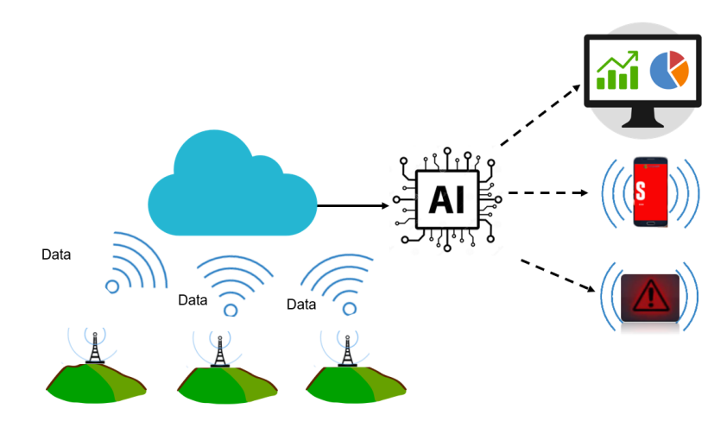

Fig: Proposed schematic expected outcomes of the system.

**BLOCK DIAGRAM**

Stage 1:

Historical Data from Open-Mateo & IMDB

EDA & Feature Engineering + Addition of Updated Dataset

Time Series Forecasting using Deep Learning

Hyperparameter Tuning

Model Testing & Validation

Model Deployment

Stage 2:

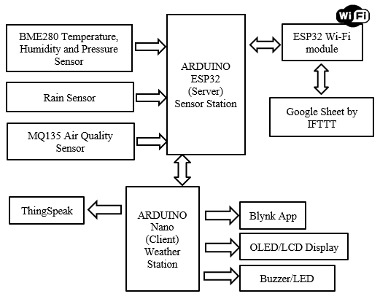

Stage 3:

Real-time Data collection form the hardware model

Input values to the Time Series DL Model

Phenomenon Prediction + Fine tuning the model on the real-time data-base (for better accuracy & dealing with climate change, so the model remains updated)

Alert System through the server

Circuit Diagram:

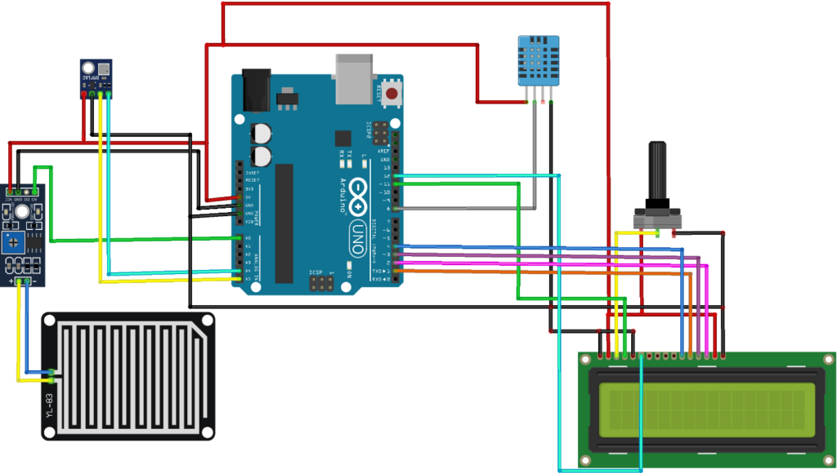

**METHODOLOGY & TOOLS USED**

**Data Collection:**

**Sources:**

1. Open-Mateo API
2. Indian Meteorological Department (IMD)

**Hardware Sensors:**

1. Temperature & Humidity Sensor (DHT22)
2. Barometric Pressure Sensor (BMP180)
3. LIDAR/Radar System
4. Rain Gauge
5. Wind Speed & Direction Sensor (Anemometer/Wind Vane)
6. Microcontroller: Arduino/Raspberry Pi
7. Communication Module: GSM/Wi-Fi/LoRa
8. Power Supply: Battery/Solar

**Exploratory Data Analysis (EDA):**

**Objective:**

Exploratory Data Analysis (EDA) is a crucial step in understanding the underlying patterns, structures, and relationships within the collected meteorological data. For the Cloud Burst Prediction System, EDA helps identify the significant factors contributing to cloud bursts, such as temperature, humidity, atmospheric pressure, and rainfall. By visualizing these relationships, we can better understand the data and prepare it for the next steps in the model-building process.

**Tools:** Matplotlib, Seaborn, Ploty, etc.

**Approach:**

1. **Data Visualization:**
   * Use ‘Matplotlib’ and ‘Seaborn’ to create visual representations of the data, such as histograms, scatter plots, box plots, and heatmaps.
   * Generate time series plots to analyse the temporal trends in key variables like temperature, humidity, and rainfall.
   * Utilize ‘Plotly’ for interactive plots that allow deeper exploration of the data, such as 3D plots or animated visualizations to see changes over time.
2. **Correlation Analysis:** Apply heatmaps using ‘Seaborn’ to examine the correlation between different meteorological variables, identifying which factors are most strongly associated with cloud burst events.
3. **Outlier Detection:** Visualize data distributions to identify and analyse outliers that might represent unusual weather patterns or sensor errors.
4. **Feature Selection:** Identify the most relevant features for model training, using visual analysis to determine which variables contribute significantly to cloud bursts.

**Data Pre-processing:**

**Objective:**

Data pre-processing is essential for preparing the collected meteorological data for model training. In the Cloud Burst Prediction System, pre-processing ensures that the data is clean, consistent, and suitable for feeding into machine learning models. This step includes handling missing values, normalizing data, encoding categorical variables, and splitting the data into training and testing sets.

**Tools:** Pandas, NumPy, Scikit-learn (sklearn), etc.

**Approach:**

1. **Data Cleaning:**
   * Use ‘Pandas’ to handle missing data, either by imputing values or removing rows/columns with significant gaps.
   * Filter out erroneous or irrelevant data, such as sensor errors or irrelevant time periods.
2. **Normalization and Scaling:** Apply ‘NumPy’ and ‘scikit-learn’ to normalize the data, ensuring that all features contribute equally to the model. This is especially important for time series data, where variables may have different units and ranges.
3. **Encoding Categorical Variables:** Use ‘scikit-learn’ to convert categorical data (e.g., cloud types) into numerical values that can be processed by machine learning algorithms.
4. **Data Splitting:** Divide the dataset into training and testing subsets using ‘scikit-learn’, ensuring that the model is trained on one portion of the data and validated on another to prevent overfitting.
5. **Time Series Pre-processing:** For time series data, ensure that the data is properly formatted with time stamps and that any temporal dependencies are maintained during the splitting process.

**Time-Series Model Execution:**

**Objective:**

The execution of time series models is critical for accurately predicting cloud bursts, which are inherently temporal phenomena. The goal is to capture the complex patterns and dependencies in weather data over time, enabling the system to forecast abrupt cloud burst events with high precision.

**Deep Learning Algorithms:**

* **Long Short-Term Memory (LSTM):** A type of recurrent neural network (RNN) designed to learn from sequential data, particularly effective at capturing long-term dependencies in time series data.
* **Recurrent Neural Networks (RNN):** A class of neural networks designed for sequence modelling, where the output depends not only on the current input but also on previous inputs.

**Tools:** TensorFlow, PyTorch, Keras, MLFlow, etc.

**Approach:**

1. **Model Design:** Start by defining the LSTM or RNN architecture using **TensorFlow** or ‘PyTorch’. The model should be designed to handle sequences of meteorological data, with the ability to capture temporal dependencies.
2. **Training:** Train the model on historical weather data, utilizing ‘Keras’ for simplifying the model-building process and ‘MLFlow’ to track training experiments and model performance.
3. **Hyperparameter Tuning:** Use tools like scikit-learn’s GridSearchCV / RandomizedSearchCV or custom scripts to fine-tune hyperparameters, such as learning rate, batch size, and the number of layers.
4. **Evaluation:** Validate the model using test data and evaluate its performance using metrics like RMSE (Root Mean Square Error) or MAE (Mean Absolute Error). Use ‘MLFlow’ to log and compare different model versions.

**Model Deployment:**

**Objective:**

Deploying the trained cloud burst prediction model on a web platform is essential for making the predictions accessible to users and ensuring that alerts can be disseminated effectively. The deployment phase involves setting up a frontend for user interaction, a backend for processing requests, and hosting the application on a cloud platform.

**Technologies:** NextJS, Flask, AWS/GCP/Azure, etc.

**Approach:**

1. **Frontend:** Develop the UI using ‘NextJS’ along with ‘TaildwindCSS’ to create a responsive, easy-to-use application. Ensure that users can easily view predictions, historical data, and receive alerts.
2. **Backend:** Set up ‘Flask’ to create RESTful APIs that interact with the prediction model. The backend will handle incoming requests, process data, and return predictions to the frontend.
3. **Deployment:** Host the application on AWS, GCP, or Azure. Use services like ‘AWS EC2’ or ‘Azure App Service’ to deploy the backend and ‘AWS S3’ or ‘Azure Blob Storage’ for static frontend hosting. Ensure that the application is secured with HTTPS and is scalable to handle multiple users.
4. **Monitoring:** Implement logging and monitoring using cloud platform tools like ‘AWS CloudWatch’ or ‘GCP Stackdriver’ to track the application's performance and address issues promptly.

**Hardware Integration:**

**Objective:**

Integrating hardware components into the Cloud Burst Prediction System allows for the collection of real-time meteorological data, enhancing the model's accuracy and responsiveness. The goal is to capture localized weather conditions, which are crucial for predicting sudden cloud bursts.

**Components:**

* **Microcontroller:** Like Arduino/Raspberry Pi,used as the central processing unit for gathering data from sensors and sending it to the cloud or the local prediction system.
* **Sensors:**
  + **DHT22:** Measures temperature and humidity.
  + **BMP180:** Captures barometric pressure.
  + **LIDAR/Radar System:** Used for cloud measurement and detecting cloud movement.
  + **Rain Gauge:** Measures precipitation levels.
  + **Anemometer/Wind Vane:** Monitors wind speed and direction.
* **Communication Modules:** Like GSM/Wi-Fi/LoRa, enables data transmission from the microcontroller to the cloud or a central server for processing.

**Approach:**

1. **Sensor Integration:** Connect sensors to the **Arduino/Raspberry Pi** to start collecting meteorological data. Each sensor will be programmed to send readings at regular intervals.
2. **Data Transmission:** Use **GSM**, **Wi-Fi**, or **LoRa** modules to transmit collected data to the central server or cloud platform, ensuring that the data is available in real time.
3. **Local Processing:** Perform basic data processing on the **Arduino/Raspberry Pi** to filter noise and prepare the data before sending it to the cloud.
4. **Power Management:** Implement a power supply system, using batteries or solar power, to ensure continuous operation of the sensors and microcontroller, especially in remote areas.

**Alert Mechanism:**

**Objective:**

The alert mechanism is designed to notify relevant authorities and stakeholders immediately when a cloud burst is predicted, allowing for quick response and mitigation efforts. The system must deliver these alerts through multiple communication channels to ensure they reach the intended recipients.

**Communication Channels:**

* **Web Notifications:** Real-time alerts delivered through the web application to logged-in users, including visual and audio signals for urgent notifications.
* **SMS Alerts:** Sent via the **GSM** module, providing direct and immediate notifications to mobile devices, especially useful for reaching users in remote areas.
* **Email Notifications:** Sent through the backend server (using services like **SMTP**) to provide detailed alerts to a broader audience, including government agencies and disaster management teams.

**Approach:**

1. **Notification System Setup:** Implement a notification system within the **Flask** backend that triggers alerts based on the prediction model's output.
2. **Web Notifications:** Integrate web push notifications into the **NextJS** frontend, ensuring users are notified in real time when a cloud burst is imminent.
3. **SMS Alerts:** Use the **GSM** module to send SMS alerts directly from the hardware setup, ensuring that key personnel receive immediate warnings.
4. **Email Notifications:** Configure the backend to send automated email alerts using SMTP services, providing detailed information about the predicted event, its location, and expected impact.

**ADVANTAGES & APPLICATIONS**

**Advantages:**

1. **Early Warning System:** Timely alerts to prevent or mitigate disaster impacts.
2. **Accuracy:** Combines deep learning and real-time data for precise predictions.
3. **Scalability:** Deployable in various regions with different climatic conditions.
4. **Integration:** Merges software and hardware for a comprehensive solution.

**Applications:**

1. **Disaster Management:** Supports timely evacuation and preparation to reduce disaster impact.
2. **Agriculture:** Aids in planning by predicting extreme weather.
3. **Urban Planning:** Provides data for infrastructure development in high-risk areas.

**MAJOR PROBLEMS**

1. **Real-Time Data Collection and Analysis:** Implementing a reliable system to collect and analyse meteorological data in real time, using hardware sensors and APIs.
2. **Climate Changes and Sudden Discrepancies:** Addressing the unpredictable nature of climate change and its impact on cloud formation, movement, and bursting.
3. **Abrupt Nature of Cloud Bursts:**

* **Challenge:** Cloud bursts often form, travel, and burst in minutes, making them difficult to predict. These events can also trigger heavy rainfall, floods, and landslides, leading to long-term damage.
* **Approach:** The system must account for the rapid development and movement of clouds, utilizing advanced algorithms and real-time data to predict such events accurately.

**FUTURE SCOPE**

**Remote Sensing and Satellite Imagery:** Satellite imagery provides high-resolution satellite data provides detailed spatial data that can be used to track cloud formation, movement, and other critical atmospheric conditions in real time.

**Approach:**

1. **Data Integration:** Incorporate satellite data into the existing dataset, using APIs from satellite providers (e.g., NASA or ESA) to access real-time imagery and weather data.
2. **Model Enhancement:** Use the high-resolution spatial data to refine the prediction model, improving its ability to detect and predict cloud burst events with greater accuracy.
3. **Advanced Visualization:** Utilize tools within the UI like ‘ShadCN’ to visualize satellite imagery alongside prediction data, giving users a more comprehensive view of potential cloud burst events.
4. **Collaboration with Meteorological Agencies:** Partner with organizations like the IMD or international meteorological agencies to access more sophisticated satellite data and integrate it into the cloud burst prediction system.

**REFERENCES & RESEARCH PAPERS**

References:

huk